Insolation and temperature

Heat is a form of kinetic energy and we might use the words interchangeably. Heat and energy refer to a quantity. Temperature is a scale of measurement. To know the quantity of heat in a certain amount of air or water, for example, we need to know how much of it there is (volume), what type of material it is, e.g., air, water, or other, and its temperature. Of common materials, water holds much more energy or heat that other substances for its volume. Moist air, that contains a lot of water vapor, holds more heat for its volume than drier air.

The dynamics or transfers of heat in the atmosphere, oceans, and other water bodies are fundamental to how water evaporates and precipitates, and the range of temperatures of materials as they heat and cool.

Some heat is added (and removed) from the earth’s interior by processes like volcanism, hot springs, radioactive decay, and subduction. However, our heat budget at and above the earth’s surface is dominated by *insolation* or incoming solar radiation.

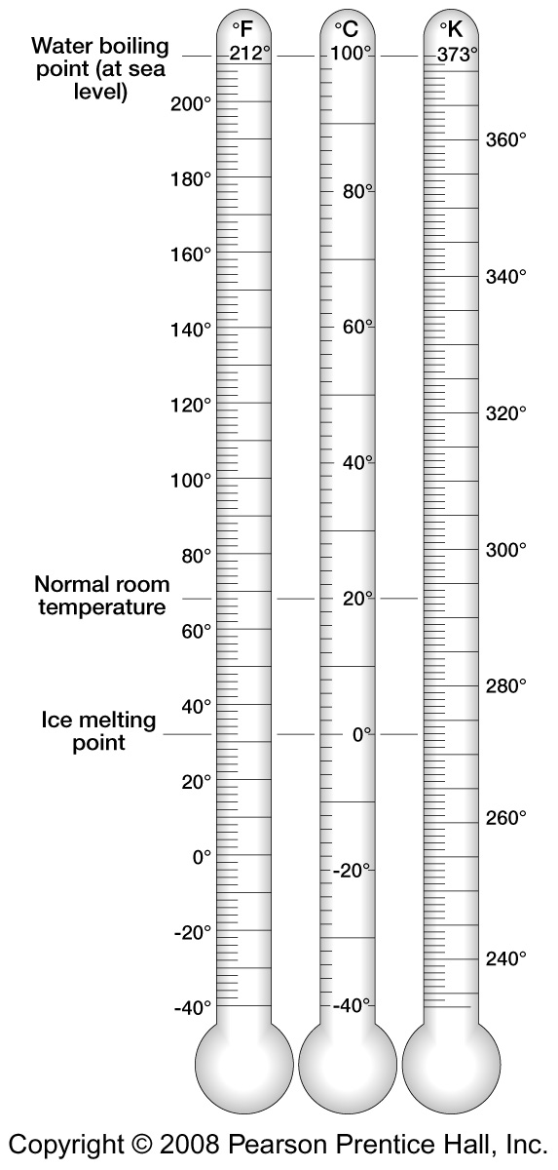

For temperature, we use the *Fahrenheit scale* which has 0-100 degrees centered over much of the range of conditions experienced at the earth’s surface. Greater than 100 degrees F is getting quite warm, and less than 0 degrees F is quite cold. The highest temperature recorded officially so far is at Furnace Creek in Death Valley, California at 134 degrees Fahrenheit. The lowest recorded temperature is at Vostok, Antarctica at negative 129 degrees Fahrenheit.

The *Celsius scale* uses phase changes of water, with water freezing at 0 degrees Celsius (-32 degrees F) and water boiling at 100 degrees Celsius (212 degrees F).

The *Kelvin scale* is the same as the Celsius scale with a shift of 273 degrees Celsius upward to have zero at a condition of no energy (absolute zero). Note that our whole universe has an average temperature above 0 degrees Kelvin. The Kelvin scale is useful for thermodynamic calculations.

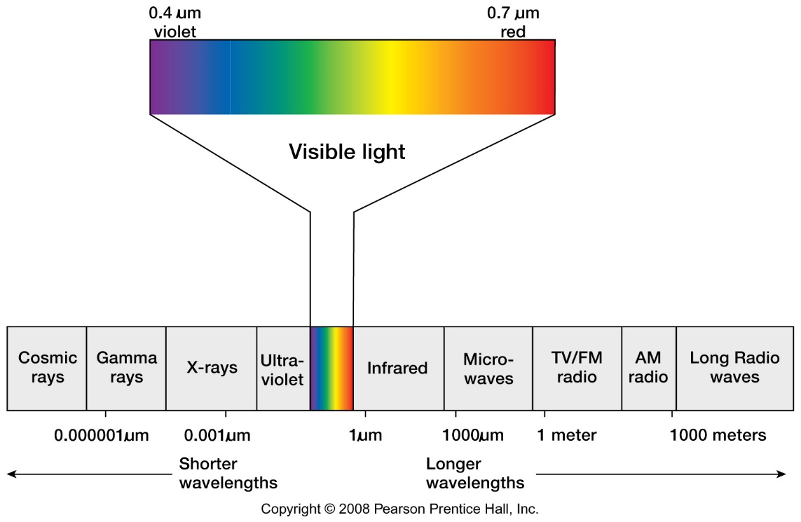

Incoming solar radiation or insolation is electromagnetic radiation (light) which includes gamma rays, X-rays, ultraviolet radiation, visible light, infrared radiation, microwaves, and radio waves. Visible light has a wavelength about the size of bacteria (microscopic). Long wavelengths of light can be the size of Mt. Everest (or Mt. Rainier) in the radio wave end of the light spectrum. All of the above are light and we only see the visible part of the light spectrum.

The amount of insolation to earth from the sun peaks over visible light and this is based on the surface temperature of the sun (600 degrees K), which emits (blackbody) radiation all directions into space.

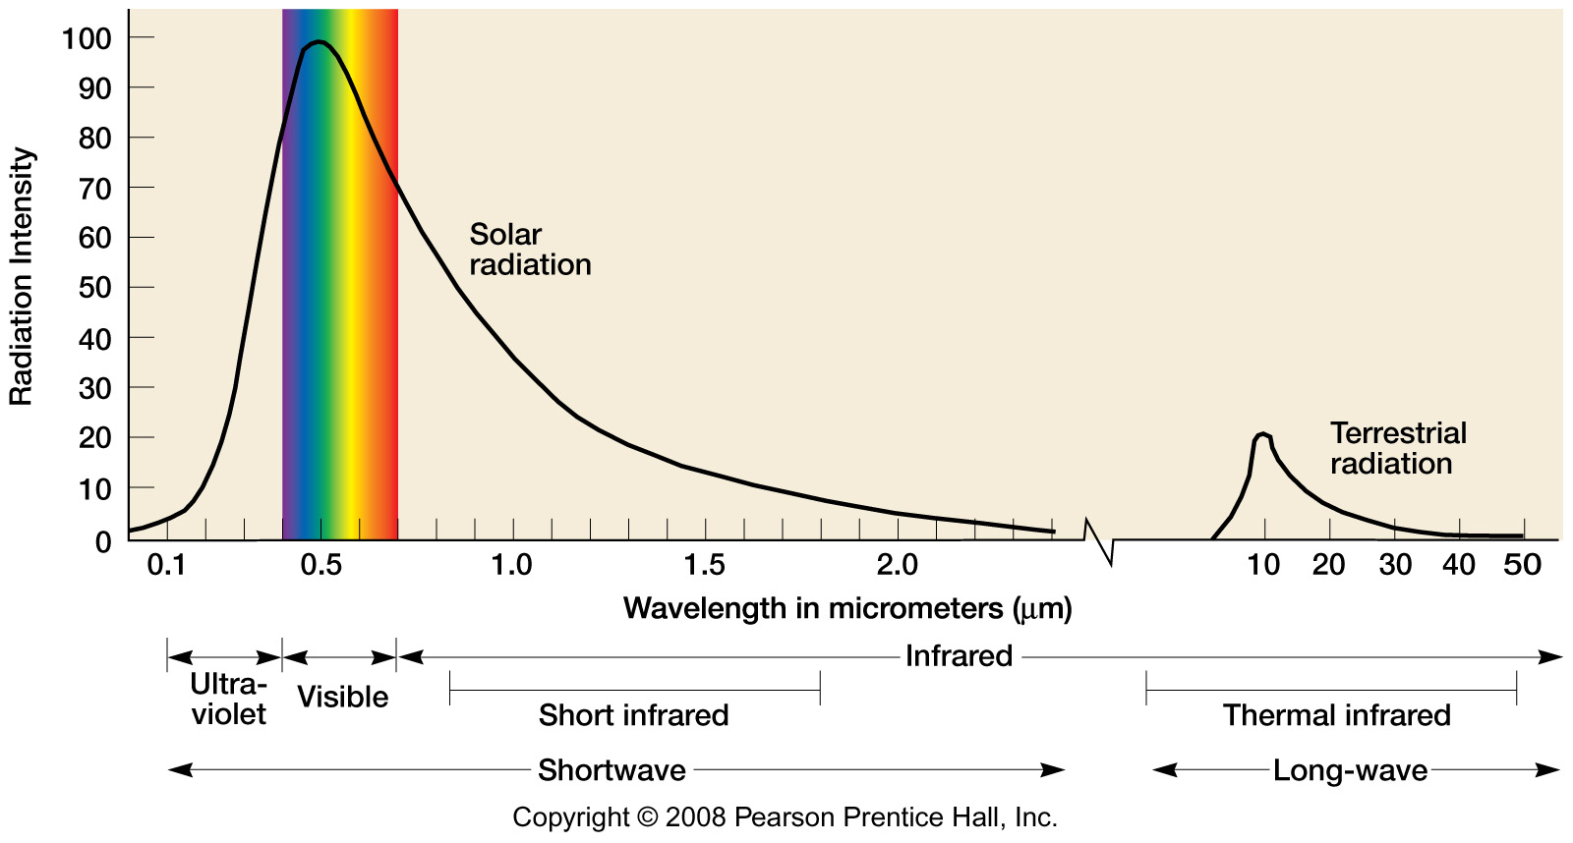

The earth reradiates energy from the air, oceans, and land that have heated up and this radiation peaks over the thermal infrared range of the light spectrum. Note that many satellite images that we use to interpret earth’s surface conditions (e.g., in lab 1) will emphasize variations in infrared radiation returned to space. This is particularly useful for analysis of vegetation, for example, we might see evidence of a diseased forest from space before we observe it directly on the ground.

*Radiation* is an emission or transfer of heat based on the temperature of the heated source object (e.g., the sun) that radiates the energy. Heat flows one way from hot to cold. Note that the sun’s energy does not heat up the space between us on the earth and the sun.

*Absorption* is an addition or assimilation of solar energy. More textured and darker materials typically absorb more heat, e.g., dark volcanic rock covering the ground.

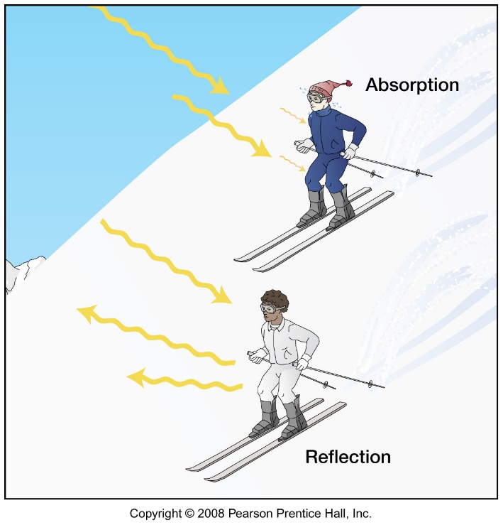

*Reflection* is the repulsion or “bouncing back” of solar energy. Lighter colored surfaces are typically more reflective.

*Albedo* is a measure of reflectance as a percentage. The average albedo for the earth’s surface is about 31%.

Fresh snow may reflect 80-95% of the sun’s energy.

Forests may have 10-20% albedo.

Crops or grasslands may have 10-25% albedo.

Asphalt (black top) may have 5-10% albedo and light-colored roofing may have 35-50% albedo.

Water may have 10-60% albedo, depending on the sun angle. There will be more reflection when the sun is lower in the sky.

*Scattering* is a redirection or refraction of light rays.

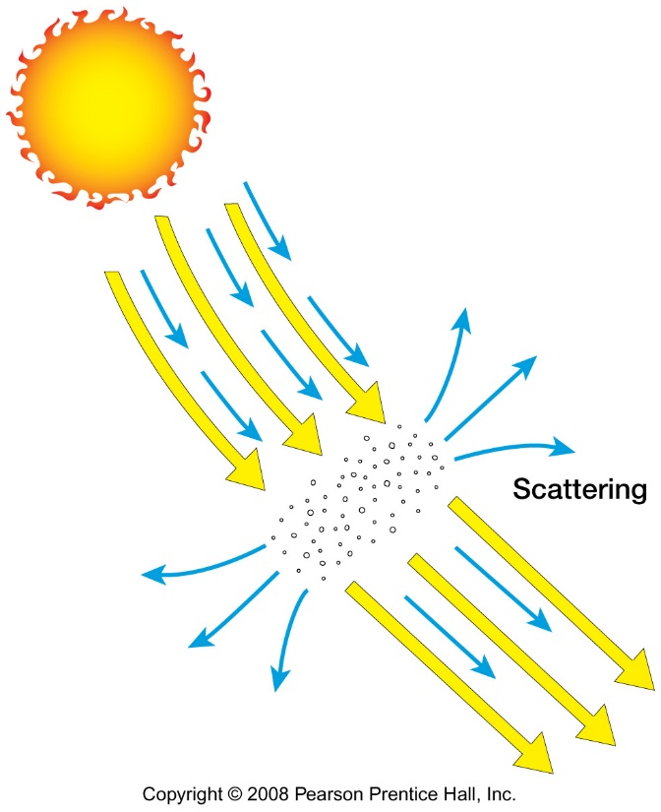

*Transmission* is the passage of light (energy) right on through. Materials such as clearer air and more transparent water increase transmission.

The *Greenhouse effect* is the interference or trapping of solar energy in the atmosphere from water vapor and greenhouse gases such as carbon dioxide, methane, ozone, and others. We will examine the Greenhouse effect further in looking at climate and climate change.

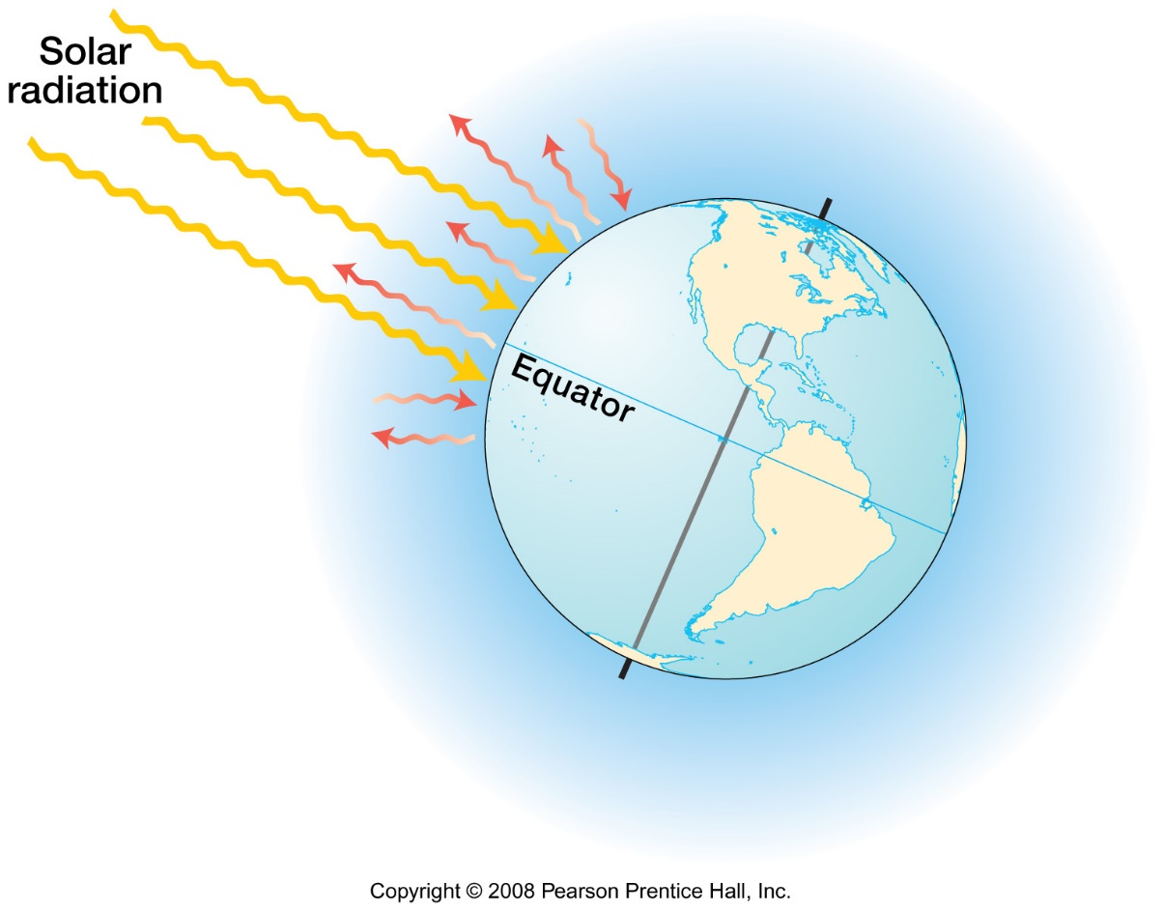

*Conduction* of heat is a direct transfer of energy between warmer and cooler material.

*Convection* of heat is the transfer energy when the heated material moves. Convection is more efficient than conduction to transfer heat. Convection works in fluids and gases, including the oceans and the atmosphere. Atmospheric convection involves vertical movement of heated air and is associated with instability of the atmosphere and severe weather. *Advection* in the atmosphere is the horizontal movement of warmer or cooler air.

*Adiabatic processes* are based on air density (pressure). If an air mass moves up or down, the density of the air changes.

With upward movement, air expands and cools adiabatically.

With downward movement, air compresses and heats adiabatically (molecules of air are closer together and collide more)

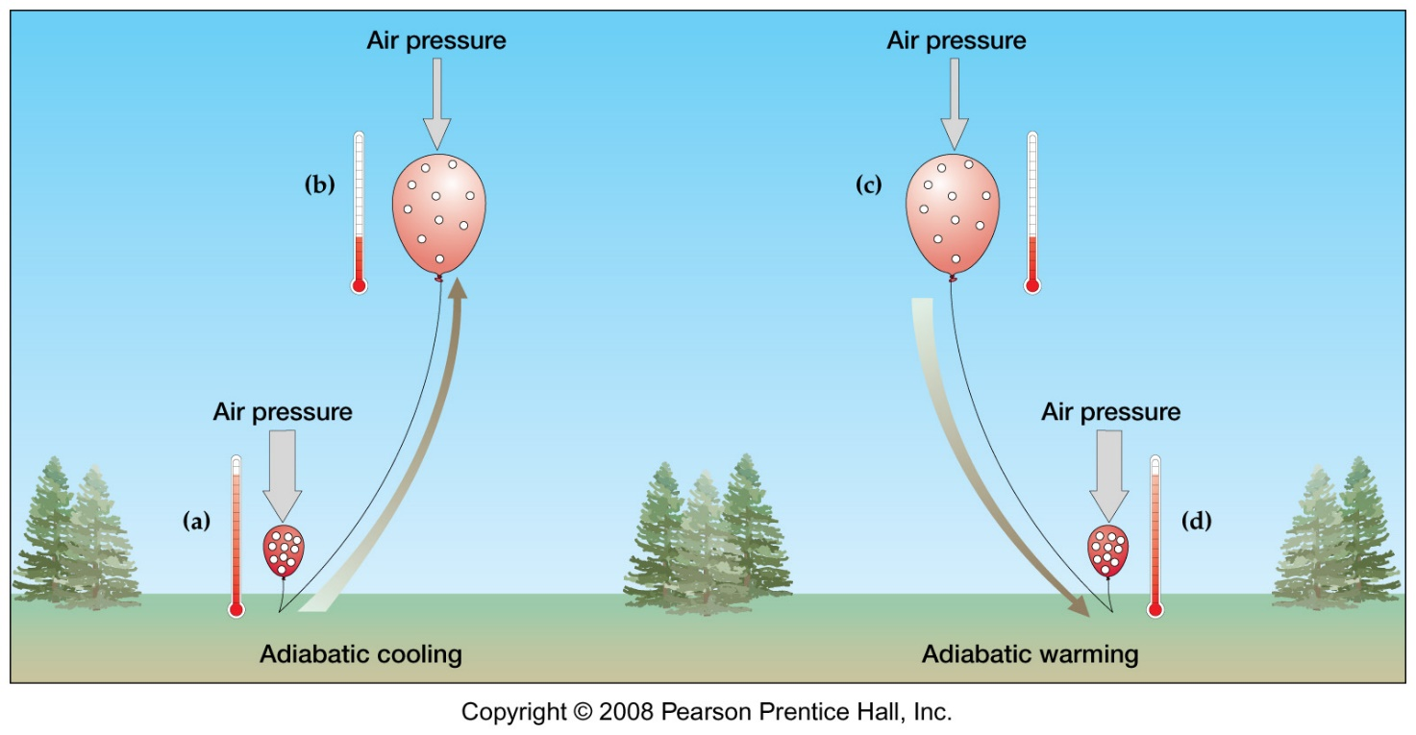

At a particular location, the air temperature will decay upward at an average (lapse) rate of 3.6 degrees Fahrenheit per 1000 feet or 6.5 degrees Celsius per 1000 meters. For example, on a hot summer day it is typically cooler higher up in the mountains.

To keep a constant temperature the incoming solar radiation (insolation), measured at the top of the atmosphere, will balance the outgoing radiation into space.

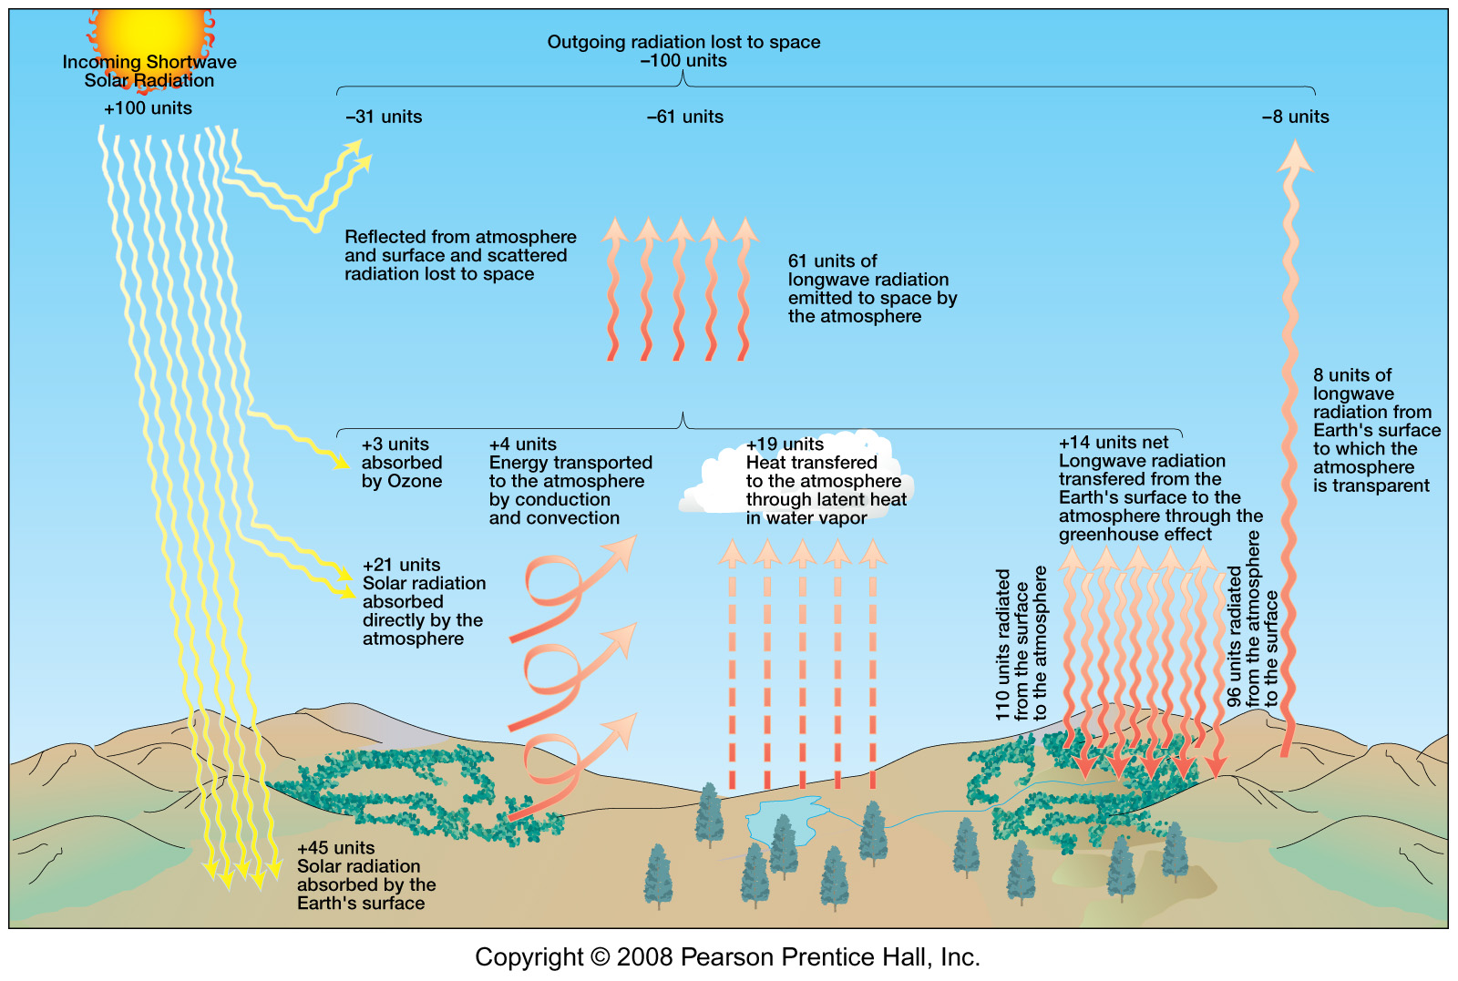

Note that in the figure (above) less than half of the incoming solar energy directly reaches the earth’s surface. Some energy is reflected (e.g., by clouds), scattered, and cycled in the lower atmosphere by reradiation, absorption, evaporation, and condensation.

Insolation varies by latitude because of the sun angle and day lengths through the year. The atmosphere is in effect “thicker” when the sun’s rays pass through the atmosphere at a lower angle of incidence.

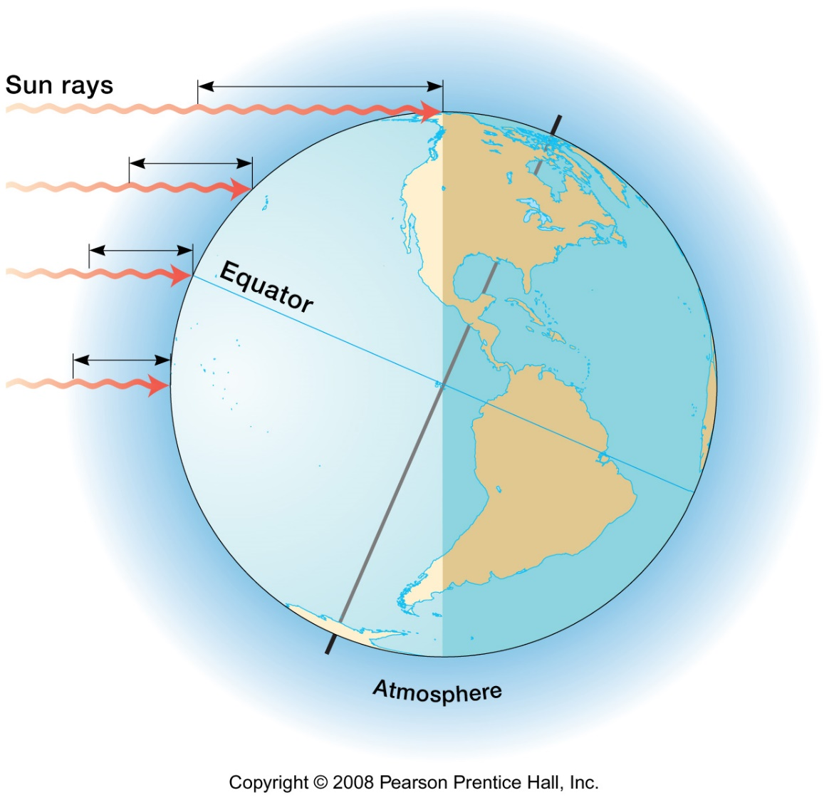

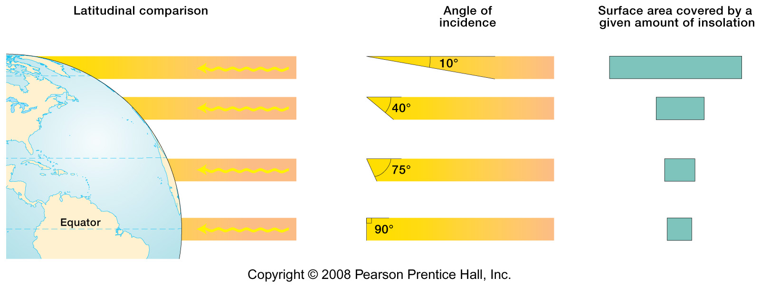

Insolation varies seasonally because of the tilt of the earth’s spin axis, relative to the sun. During the Arctic or Antarctic summer, the sun is up through all 24 hours and comes in at a low angle.

Land heats up more quickly and cools down more quickly than water in response to solar radiation.

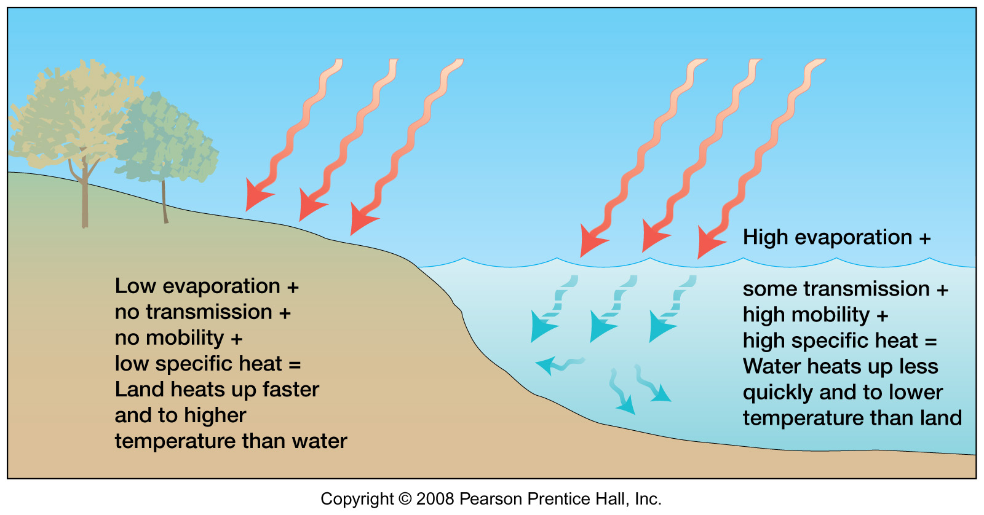

Water has a very high specific heat or heat capacity, storing a lot of energy for its volume. We measure the specific of other substances as a decimal relative to water, which has a specific heat of 1. The heat capacity of water is about 5 times the heat capacity of land.

Water can transmit the sun’s rays up to several hundred feet or more, storing heat in a much greater volume than land, which only heats up within a few inches or centimeters of the surface.

Water is mobile, dispersing the solar energy over a greater volume than land.

When water evaporates, heat is absorbed and stored in water vapor, cooling the air around it*. Sensible* or felt heat goes into storage as *latent* or stored heat during evaporation, therefore, evaporation cools the air. During condensation or precipitation, latent heat is converted to sensible heat and the air heats up.

*Atmospheric and oceanic circulation* are linked and redistribute energy over the earth, responding to the earth’s rotation or Coriolis effect. Elliptical *gyres* rotate in a clockwise direction in the north Atlantic and north Pacific oceans, and a counterclockwise direction in the south Pacific, south Atlantic, and Indian oceans.

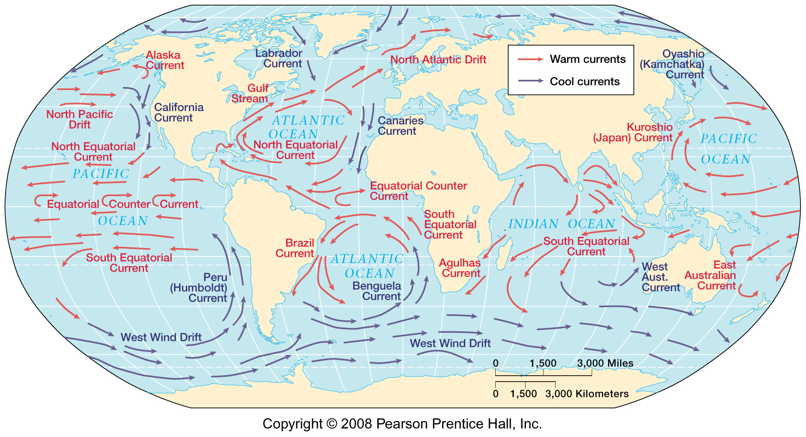

Cooler currents sweep the eastern sides of the Pacific and Atlantic oceans, such as the California current and the Peru (Humboldt) current (above left).

Warmer currents follow the western side of the Pacific, impacting Japan and eastern Australia with warmer water at a higher latitude. The Gulf stream is a warm current impacting the Gulf of Mexico and eastern North America, shown on this thermal image (below)

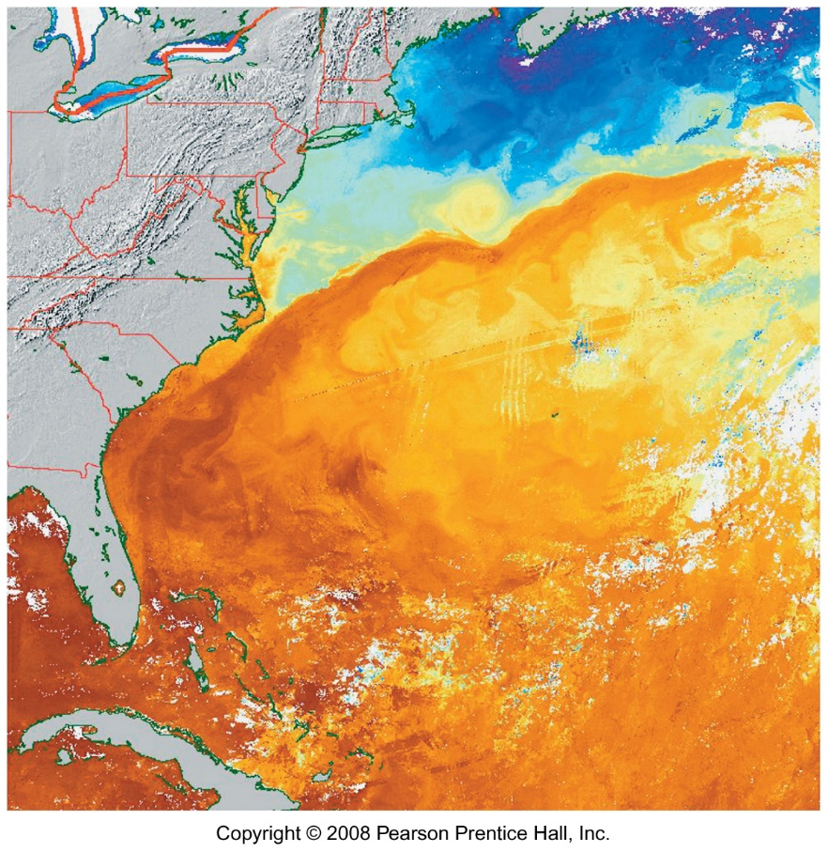

The currents intensify toward the western sides of the oceans, driven by the Coriolis effect and become narrower, faster, and deeper. The Gulf stream is an example of western intensification, as well as the Kuroshio (Japan) current.

Upwelling of ocean water is a response to currents pulling away from the coastline, e.g., along the west coast of South America.

*Controls of temperature* include:

*Latitude*, with a general decrease in temperature away from the equator. The thermal equator shifts southward during the northern hemisphere winter and northward during the northern hemisphere summer.

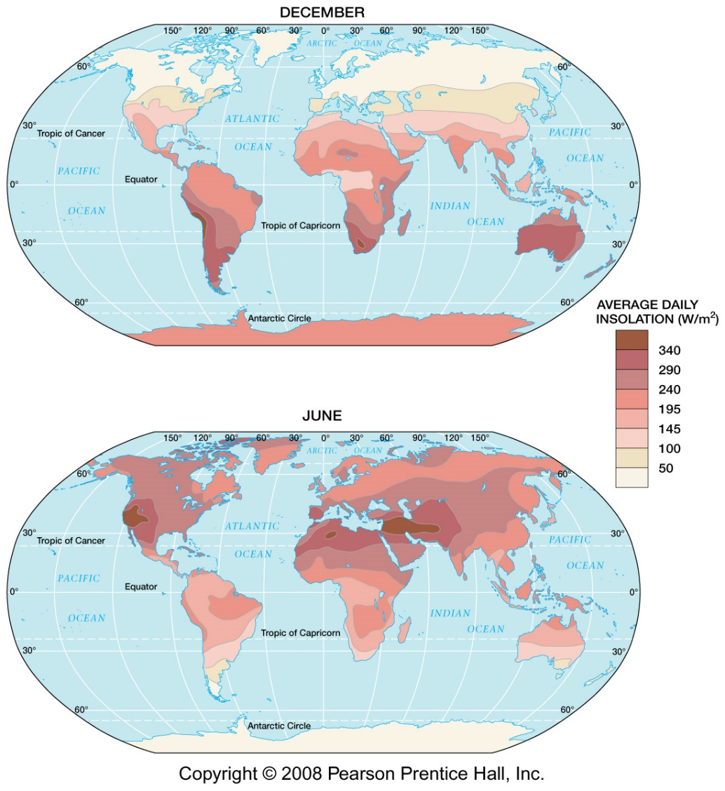

*Altitude* controls temperature, which generally decreases between lower and higher elevations at a particular location.

Note that the area of the highest recorded temperature in Death Valley, CA is also a low spot in the northern hemisphere (282 feet or 86 meters below sea level) After visiting this hot spot (Badwater basin, Death Valley) in the morning, the author was several thousand feet above the basin looking down, in the afternoon, and the temperature was comfortable.

*Land and water contrasts* are very important temperature controls. At a similar latitude, summer temperatures are higher over the continents and winter temperatures are colder over the continents when compared with the coasts.

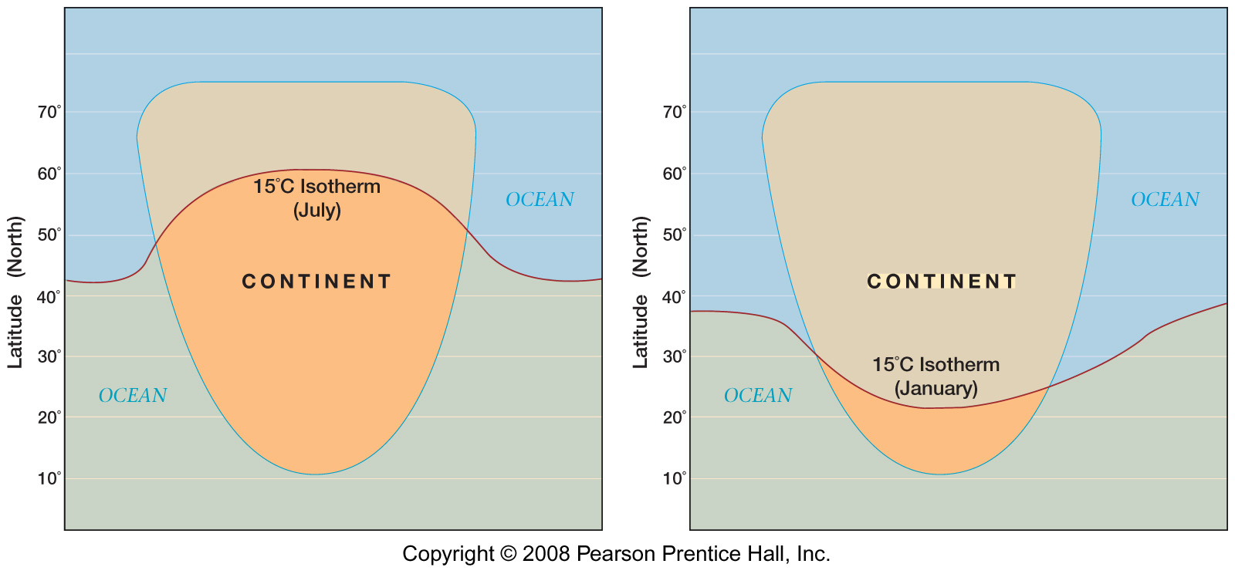

A cool ocean current will moderate summer temperatures more in a coastal area, and a warm ocean current will moderate winter temperatures more in the coastal area.

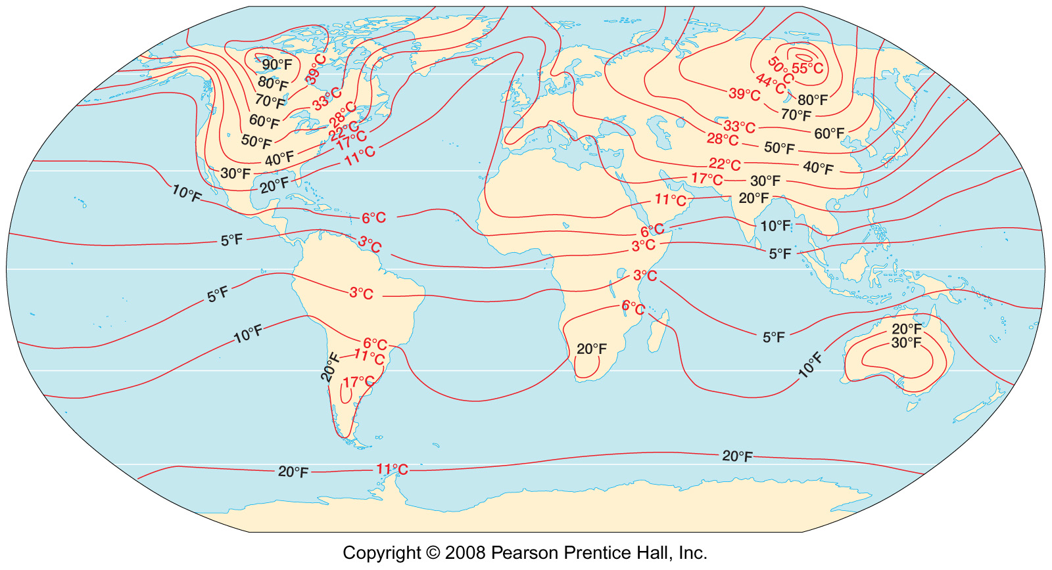

The temperature range and temperature extremes are greater over land areas in the higher latitudes (above).